..
….. | 6 | 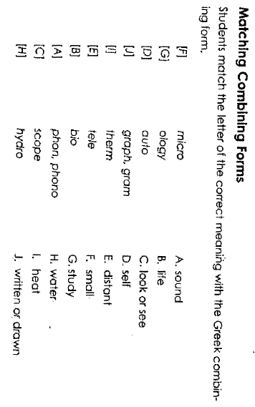 | 4 Can you think of some words with  ped or pod?  ………………………………………………………….  …………………………………………………………...  ………………………………………………………….  ………………………………………………………….  …………………………………………………………...  ………………………………………………………….  …………………………………………………………...  ………………………………………………………….
8 | 1  - Plic, ply (to fold)  - Scrib, script (to write)  - Duc, duce, duct (to lead)  - Tend, tens, tent (to stretch or strain)  - Mit, miss (to send)  - Ten, tain, tin, tinu (to hold)  - Spec, spect, spic (to see, watch, or observe)  - Fer (to bear or yield)  - Fac, fact, fect, fic (to make or do)  - Sist, sta, stat, stit (to stand)  - Pon, pose, pound (to put, place, or set)  - Cap, ceit, ceive, cep, cip (to take, catch, seize, hold, or receive) | 2  Activity 1: In pairs list as many words you can using one “group” of roots.  …………………………………..  ……………………………………  …………………………………..  ……………………………………  …………………………………..  ……………………………………  …………………………………..  ……………………………………  …………………………………..  ……………………………………  …………………………………..  …………………………………… | 3  Common prefixes  ……………………………………  …………………………………..  ……………………………………  …………………………………..  ……………………………………  …………………………………..  ……………………………………  …………………………………..  Common suffixes………………  …………………………………..  ……………………………………  …………………………………..  ……………………………………  …………………………………..  …………………………………

..
..
..

